**Ideation Phase**

**Brainstorm & Idea Prioritization Template**

|  |  |
| --- | --- |
| Date | 17 September 2022 |
| Team ID | PNT2022TMID29514 |
| Project Name | Project - Fertilizers Recommendation System For Disease Prediction |
| Maximum Marks | 4 Marks |

**Brainstorm & Idea Prioritization Template:**

Reference: [https://app.mural.co/invitation/mural/vickyg9846/1664038363528?sender=u424bdabf5d969745fe7 f0666&key=3eace548-a8cb-4ff6-a00d-91c495ba1383](https://app.mural.co/invitation/mural/vickyg9846/1664038363528?sender=u424bdabf5d969745fe7f0666&key=3eace548-a8cb-4ff6-a00d-91c495ba1383)

**Step-1: Team Gathering, Collaboration and Select the Problem Statement**

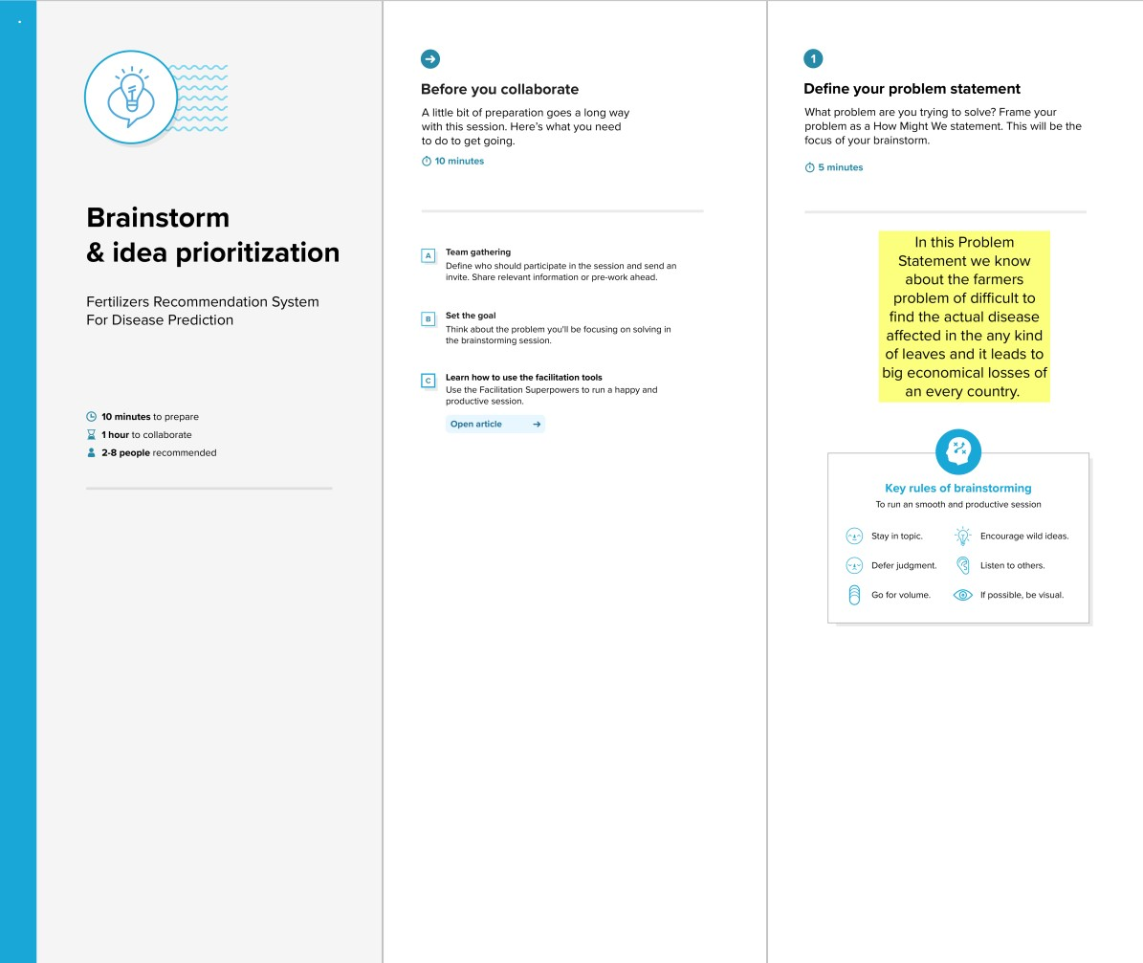

**Step-2: Brainstorm, Idea Listing and Grouping**

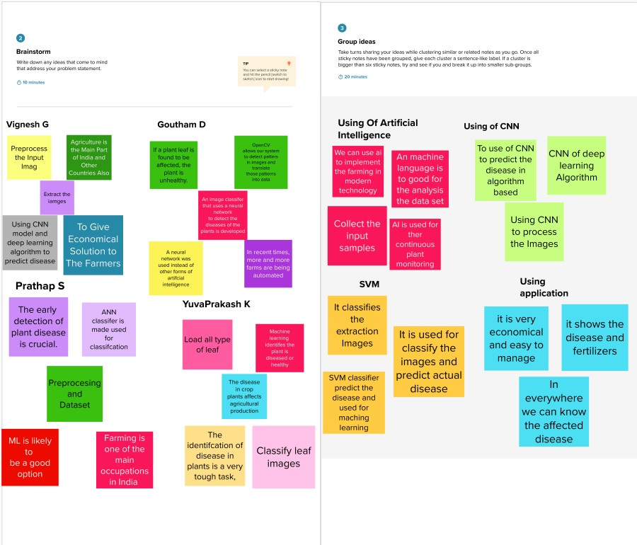

**Step-3: Idea Prioritization**

